1. Profile of the country situation

Introduction
Lithuania is a country and the southernmost of Europe’s Baltic States that borders Poland, Latvia and Belarus. Population - 2.956 million (2013, World Bank). Lithuania covers the area of 65 302 km². Lithuania is a flat land with plains covering approximately 75% of the country. Climate ranges between maritime and continental. The average temperatures are +19°C in July and -3°C in January. Our climate is not among the mildest. On the other hand, we may enjoy the four clearly pronounced seasons: a beautiful and long blooming spring, almost 20 hour-long midsummer days, the golden autumn and a deep snowy winter.

Lithuania and its main characteristics
In Lithuania as well as in many other fast developing countries, tourism is becoming a very important and fast growing industry, where rural tourism is a very important part. Most of the tourist are local, foreigners just 9,2 % from all the tourists.
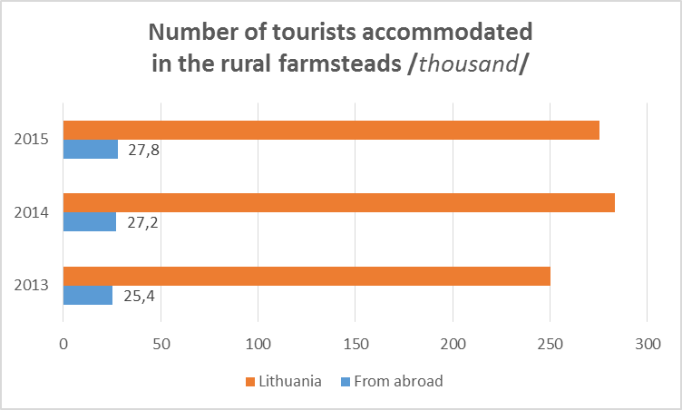
The Lithuanian recreational potential in the development of rural tourism is extremely diverse – it consists of forests (32 per cent of the country’s territory), a dense network of internal waters (2,850 lakes and 758 rivers), cultural heritage objects and traditional crafts, the location of which distinguishes the priority territorial rural tourism development regions. Lakes and forests of East Aukštaitija, forests, rivers and lakes of Dzūkija, highlands in Žemaitija, and the Seacoast Region.
Rural tourism is an important part of the Lithuanian tourism sector, affecting the image formation of the state or the region and promoting the growth of inbound tourism. The development of rural tourism generates economic, social and cultural, and ecological benefits for countryside, regions and country as well. According to the impact of technology on tourism sector our aspirational would be to maximize the new opportunities it creates, to improve the competitiveness of destinations and to manage our natural resources more effectivel.

Overall situation and trends in Lithuanian rural tourism
People involved in rural tourism in Lithuania understand that rural tourism is not the ordinary accommodation business. It requires much more. Accommodation becomes not as important as activities in rural area. Moreover, this is core change as accommodation service was the base for rural tourism for years. The visitor may be offered not only a stay for a night but also the activity program. Guests may see or even feel something new, never experienced before. Such holidaymaker sees how the host lives, his everyday life, and may experience all that himself as if he is a member of the family. Most of the homesteads are usually situated near water – lakes or rivers, and the owners have a variety of fun to offer to their guests, from sauna or outdoor bath barrel in which even the hardest frost is not to be feared (and just think of the romance floating in the air under a starry night sky!) to basketball or volleyball courts, bikes, boats or canoes.
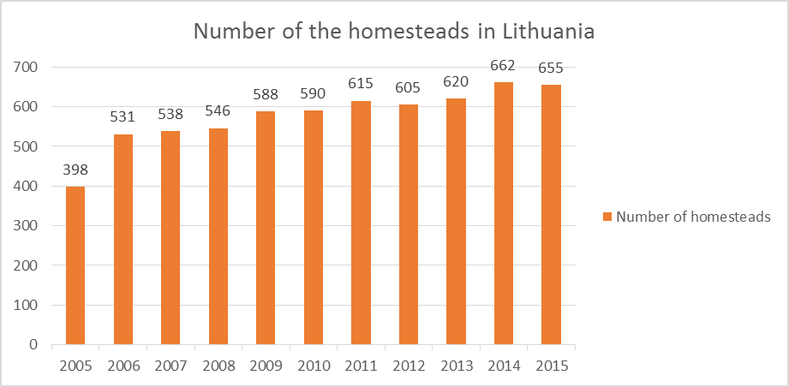
Growth of the homesteads over the last 10 years (Statistics Lithuania, 2016)

A few years ago, 99% of our members were accommodation providers, who were focusing on accommodation and hospitality quality. Last year we started marketing activities, because we see the potential for the activity providers in the rural territory.
In order to attract more visitors to rural tourism homesteads, the owners have to offer a wide range of services with its specialization. Providing specialized services of rural tourism is a particular challenge in order to increase the competitiveness of rural tourism. There are 10 main specializations of rural tourism: cultural recreation, wellness homesteads, family celebrations, environment-friendly homesteads, agro tourism homesteads, culinary heritage, active holidays, holidays for families, peaceful holidays, business events. Rural tourism homesteads in Lithuania are classified according to the level of service and comfort by using the system of storks (1 stork – the lowest level, 5 storks – the highest level).

Needs of ICT training in tourism sector applied for the Lithuanian case
As we all know, the Information Communications Technologies (ICT) plays a major role in tourism sector. The integration of ICT in the tourism, travel and hospitality industry is an essential for success of tourism object. ICT allows an individual to access the tourism products information from anywhere any time. ICTs facilitates a variety of operations: service or product selection, ordering, fulfillment, tracking, payment and reporting to be performed with one easy to use tool.
Considering the situation in rural tourism sector in Lithuania we face with these opposites:

RT provider | RT customer
Lives in rural area, where mobile connection is usually poor; | 70% spend 2-4 hours per day on internet
Average age of the services provider - 53,5; | Age 21 – 50
RT is an alternative activity ; | Having average income
Checks e-mails 3 times a week; | Traveling with family and kids
Some of them use – Explorer 5 | Android Browser usage - 181, 36%
.
Rural tourism services providers know, that personal service and hospitality is great advantage and the ICT is a challenge, challenge to change.
Based on various surveys and consumer studies on online travel booking trends, we know that:
- Internet is the number one source of travel information and inspiration.
- More and more travelers around the world are booking online (and via mobile devices).
- Travelers find information in various ways, including social media, peer reviews, search, advertisement, and more.

We see, that our members need to improve competitiveness and sustainability of rural tourism businesses, they lack digital marketing, use of social media skills, online sales and communication skills with the customers in the public space. And sometimes they just need the common understanding, that internet tools can certainly improve their business.

Presentation and description of relevant and successful case studies

Homestead Aliai, Aukštaitija region

A bowery founded by owner grandfather in the year 1871 offers serenity, private stay and comfort. Log cottages, a steam bathhouse and exclusive entertainment, i.e. flights by planes and gliders as well as croquet grounds are at your service. Quests are welcome to enjoy a pond stocked with fish, bicycles, shooting range and pottery workshop. Several lakes and Aukštaitija National Park are found nearby.
Hosts offers their guests to remember the taste of true country / ecological products. Depending on the season, they offer some cottage cheese, curd, fresh raw milk, country eggs, herb teas, homemade apple juice, in the summertime - crayfish, in autumn – apples.
Hosts cordially invite all their guests to travel along the pinewood paths, to see many lakes, to visit interesting natural objects, museums, hill forts located in the Park. Mushroom and berry pickers can always fill their baskets here, and fishermen can rent a boat and enjoy the catch. They offer all necessary maps of the Park.
Homestead has it’s logo. Hosts speaks English, Russian. They have active Facebook account and also blogger - http://aliaiblog.blogspot.lt/ . The homestead has been on Booking.com since 6 Dec 2011, their review score on booking.com is 9.3. Their website http://aliai.lt/en/

Homestead „Dzukijos uoga“, Dzukija region

The luxury countryside homestead is designed for holiday entertainment of a circle of friends or co-workers up to 15 people. Located on a picturesque lake and offering a private beach area, within the Dzūkija National Park. The owners of the homestead seek to live in harmony with the nature and provide a tailor-made entertainment in nature with personal touch. The new built houses with ethnographic outer look have all amenities. The catering of regional cuisine, as well as a bonfire with meal preparation can be arranged by the property upon request. Guests can also explore the nearby forests and go picking berries and mushroom. An array of activities can be enjoyed on site or in the surroundings, including canoeing, walking tours, skiing, cycling and darts. The property offers free parking and body treatments in Lithuanian sauna.
The owners organize excursions to ethnographic villages and nature viewpoints in Dzukija National Park. Charming atmosphere that will give you inner peace and harmony…
Homestead has it’s logo Hosts do speak English! This property has been on Booking.com since 21 Feb 2014 and their review score is 9.9. They have Facebook, YouTube, twitter and Pinterest active accounts. Their website - http://kaimoturizmosodyba.eu/en/

With these two examples we want to show, that both homesteads are providing not only the accommodation services, they offering various additional attractions, fully exploiting their environment, helping customers to gain new experience in their homesteads, using internet tools in their business and understand the force of the digital marketing and communication with the customers. Using digital marketing, they are more visible, more attractive for the customers, more reachable. E-tourism helps manage their business – get more customers, maintain competitiveness, use of the environment and offer the highest quality of service.

2. Survey
Introduction
The survey was carried out in Lithuania by two partners in the project from the country – Lithuanian Countryside Tourism Association and Kaunas Science and Technology Park. Survey monkey (online survey platform) was used to approach the respondents and invitations to participate in the survey were sent out by emails using the database of tourism service providers from Lithuanian Countryside Tourism Association as well as publicly available contacts.
There were more than 400 service providers contacted and 200 responses received. The response rate of 50 % is considered moderate as the survey was conducted in the winter period (December, 2015 – February, 2016) and many tourism service providers in rural areas are not operating the services in the season.

Sample of participants
The absolute majority of the respondents operate a farmhouse or country house type of business (93% or 186 out of 200). The rest come from hotel business (not related to country side tourism) – 2%, home holiday rentals – 2%, local product sellers, camping, travel agents – 1% each.
Again, the absolute majority of respondents operate in a countryside area (85,5%), while 8,5% of respondents come from small cities/villages. Graphical visualization of distribution of respondents by represented areas/regions is provided in the figure 1.

Figure 1. Distribution of respondents by area/region

The participants of the survey represent businesses of different sizes. Distribution of this index is very equivalent and varies between 10,5% (up to 10 places group) and 35,0% (10-20 places group).
The majority of reached respondents represent small (or micro) businesses and are run as private or family business (63%) or with 1-3 employees (21,5%).
As to relevance to the project, the survey has addressed very important issues such as availability of a website, usage of social network platforms, booking tool availability, feedback and comment gathering measures, etc.
The responses show that more than ¾ (75,5%) of tourism business providers have their website. However, only ¼ (24,5%) of them have developed the website by themselves.
Slightly more than half (57%) of respondents indicated that they use social networking tools in order to promote their businesses.
The majority of respondents (189 out of 200 or 94,5%) have indicated that they receive booking or service requests via electronic tools, whether website, email or social network. However, the intensity of such bookings varies between 13,5% (always receive booking by e-tools) and 29,5% (more than 50% of bookings).

Briefly comment the responses from a national point of view
77,5% of respondents have indicated that they operate all year round. It leads to an assumption that the survey has not reached the target audience which represents those working during summer time or seasonally. This fact suggests that, in order to approach the target group as wide as possible, partners will have to consider other tools to address the audience when the pilot testing phase of the project will be implemented.
More than 1/3 (36,42%) of the service providers have developed their website presence more than 5 years ago. The dynamics of IT technologies conditions that usage of most current IT solutions gives the best results in e-marketing and these solutions change every 2-3 years. Therefore having such a substantial share of old solutions among target audience suggests and justifies the need for the EKITour platform in order to increase the computer and e-marketing literacy among service providers in tourism sector.
89,47% or 102 out of 114 respondents rely on a single social networking tool – Facebook. However, the possibilities of web marketing is much higher especially nowadays when the younger generation (or the target market of project’s target audience) is digitalized and search for information on the web mostly.
The size of tourism sector businesses (see figure 2) suggest to develop the web marketing tools which do not require much time as the businesses are very small and other everyday tasks take the bulk of the time.

